

Muhammad Talha
2330-0141
BS AI

Lab 11

Question no 01

Add a shared resource counter that increments inside the critical section

Code

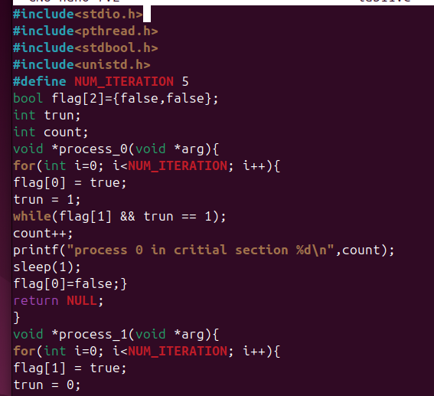
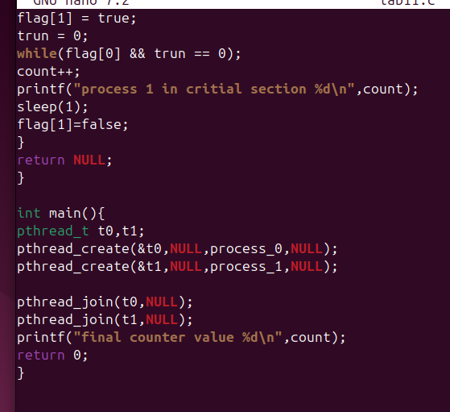

Output
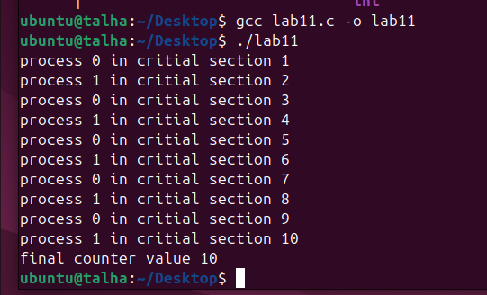

Question no 02

Experiment with different sleep times for processes and observe the impact.

Code

Process 1

Sleep (5);

Process 2

Sleep(6);

Output

